2014-SK-01-EN Stickers
0 hard | I: medium | II: easy | III: ---- | IV: ----

Answer Type: Multiple Choice Mandatory for: none

Body

Beaver Johnny put stickers on the paper. He first uses a the picture of the sun, then a cloud, a tree, a car, and a beaver.
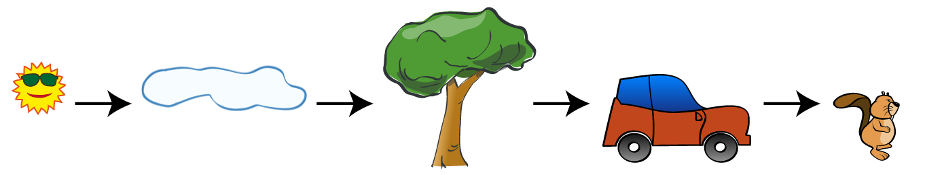

Question

Which picture has he created?

Answer

A)  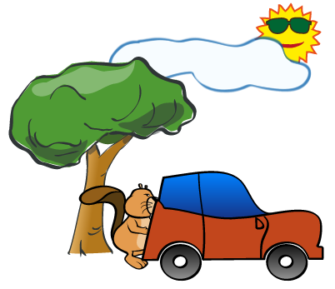 | B)  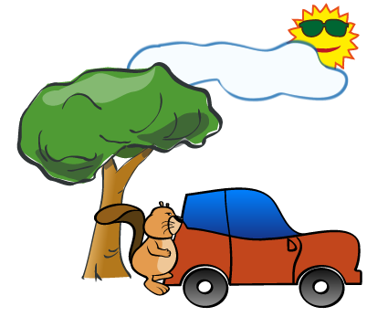
C)  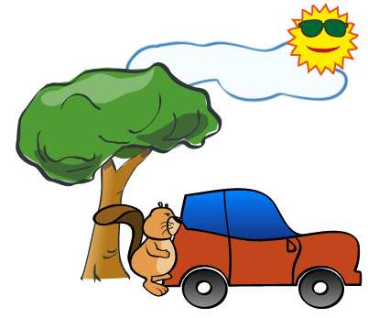 | D)  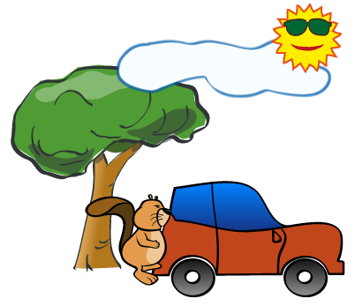

Explanation

The correct answer is B.
The sun was used before the sun, thus it has to be behind it, which makes answers C and D incorrect. The beaver came last so must be on top, hence the answer A in incorrect.

It's informatics

The order of actions and their final result are among the most common things which informatics deals with. Moreover, understanding this particular task gives you useful knowledge for using graphical editors.

Keywords

order of actions, use of graphical editor

Websites

Internal Use

Wording

"Each one on top of previous ones" is important, but it may need care in translation to say it clearly enough for the age group (even when translating to proper English).

Comments

Author, e-mail, Date (YYYY-MM-DD), Comment.

Graphics

All graphics was created by the original author of the task.

Files

2014-SK-01-EN Robot painting.odt (this file)
2014-SK-01_all.svg
2014-SK-01_stickers-a.png
2014-SK-01_stickers-b.png
2014-SK-01_stickers-c.png
2014-SK-01_stickers-d.png

Authorship

Monika Gujberová, mgujberova@gmail.com , Slovakia.

Janez Demšar, janez.demsar@fri.uni-lj.si, Slovenia – changed the text to stickers and added images

License

Copyright © 2014 Bebras – International Contest on Informatics and Computer Fluency. This work is licensed under a Creative Commons Attribution-NonCommercial-ShareAlike 3.0 Unported License (CC BY-NC-SA 3.0). Visit: http://creativecommons.org/licenses/by-sa-sa/3.0/

